**CHAPTER-2**

**ANALYSIS**



* 1. **Requirement Analysis**

Aim of this website is to understand the exact requirements of the customer and to document them properly. It will also reduce the communication gap between developers and customers.

Types of users in our new system are:-

* Admin
* Event organizer
* Client
* Event manager

**Admin:**

* Admin directs the whole website.
* Looks after the website on regular basis and can make changes.
* They ensure security measures for the users.
* Troubleshoot issues and the outages.
* Incharge of all the panels provided.
* They generate the backups on daily basis.
* Event organizer:
* Organizes the event panel accordingly.
* Notifies about the upcoming events.
* Terms and conditions of the events.
* Posting about the regular events.

**Client:**

* They must register themselves to the websites.
* Can access areas and features of the website.
* Access to offers and coupons.
* Access to map for locating nearby events.
* Provides feedback system.

**Event manager:**

* Mediator between the Admin and Event organizer.
* Searches for all the nearby event places.
* Deals with the event organizers.
* Schedules the meeting between admin and the event organizers for further procedure.

* 1. **Project Model**
* **Iterative Waterfall Model**

The Iterative waterfall model provides feedback paths from every phase to its preceding phases.

In the Iterative model, iterative process starts with a simple implementation of a small set of the software requirements and iteratively enhances the evolving versions until the complete system is implemented and ready to be deployed.

An iterative life cycle model starts with specifying and implementing part of the software, which is then reviewed to identify further requirements.

* **Iterative Waterfall Model**

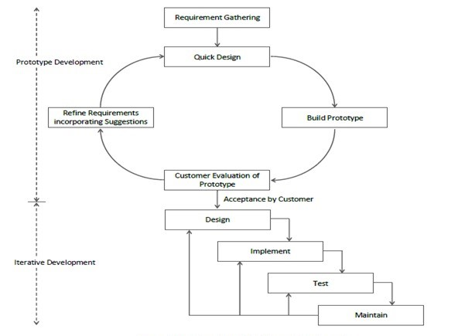

**Figure 3**

* **ADVANTAGES**
* The model is more flexible and less costly to change the scope and requirement.
* User gets a chance to experiment with partially developed software.
* This model helps finding exact user requirement.
* Feedback providing at each increment is useful for determining the better final product.
  1. **Schedule Representation**

Generalized project scheduling tools and technique can be applied with little modification to software projects. Project evolution and review technique and critical paths method are two project scheduling method that can be applied to software development. Both techniques are driven by information already developed in earlier project planning activities**.**

|  |  |  |
| --- | --- | --- |
| **ACTIVITY** | **START DATE** | **FINISH DATE** |
| Requirement Analysis |  |  |
| System Analysis |  |  |
| System Design |  |  |
| System Coding |  |  |
| Testing and Integration |  |  |

* 1. **Feasibility Study**

1. **Economical Feasibility:**

The system being is economic with respect to client or software development company point of view. It will not take any extra charges or high rates from clients for registration but, for event organizer company charges would be taken.

**2. Technical Feasibility:**

This system will be technically feasible as it runs on PHP which is open source so one will not have to take/pay any licensing.

**3. Legal feasibility:**

This system will be legally feasible as it does not have any functionality that is performed without any permission or illegally.

**4. Environmental feasibility:**

This system is environmentally feasible as it does not require any type of resources that harms nature or human as it runs on server.